Purpose
To ensure parents and school staff understand the supervision and yard duty responsibilities of the school.

Scope
The Principal is responsible for ensuring that there is a well-organised and responsive system of supervision in place during school hours, before and after school, and on school excursions and camps.
This policy applies to all teaching and non-teaching staff at Hampton Primary School, including education support staff, Casual Relief Teachers and visiting teachers.
School staff are responsible for following reasonable and lawful instructions from the Principal, including instructions to provide supervision to students at specific dates, time and places.

Implementation/ Process

Before and after school
Hampton Primary School’s grounds are supervised by school staff from 8:45 until 15:45. Outside of these hours, school staff will not be available to supervise students unless students are participating in an official activity such as sports training that is being supervised by a staff member.
Parents and carers should not allow their children to attend Hampton Primary School outside of these hours. Families are encouraged to contact Team Kids on 0405 688 149 or refer to www.teamkids.com.au for more information about the before and after school care facilities available to our school community.
If a student arrives at school before supervision commences at the beginning of the day, the Principal or nominee staff member will consider whether it is appropriate to follow up with the parent/carer to:
- advise of the supervision arrangements before school
- request that the parent/ carer make alternate arrangements.
- place the student in the out of school hours care program
If a student is not collected before supervision finishes at the end of the day, the Principal or nominee staff member will consider whether it is appropriate to:
- attempt to contact the parents/carers
- attempt to contact the emergency contacts
- place the student in an out of school hours care program (if available)
- contact Victoria Police and/or the Department of Health and Human Services (Child Protection) to arrange for the supervision, care and protection of the student.
School staff who are rostered on for before or after school supervision must follow the processes outlined below.

Yard duty
All staff at Hampton Primary School are expected to assist with yard duty supervision and will be included in the weekly roster.
The Principal [or alternative nominee] is responsible for preparing and communicating the yard duty roster on a regular basis. At Hampton Primary School, school staff will be designated a specific yard duty area to supervise.
The designated yard duty areas for our school (as of Term 2 2022) are
Zone | Area
Zone 1 | Front
Zone 2 | Middle
Zone 3 | Oval
Zone 4 | Side
Zone 5 | Library

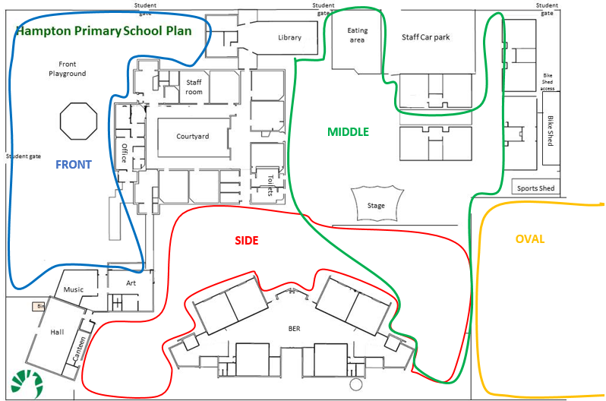

School staff must wear a provided safety/hi-vis vest whilst on yard duty. Safety/hi-vis vests will be stored in the staff room.
Staff who are rostered for yard duty must remain in the designated area until they are replaced by a relieving teacher.
No all areas are supervised at all break times, for example, the Library which will only be supervised when possible.
During a wet-day or hot-day timetable where students must remain indoors, classroom teachers are responsible for supervising students in their classroom and adjoining classroom. This supervision should be split evenly between the two teachers.
During yard duty, supervising staff must:
- methodically move around the designated zone
- be alert and vigilant
- intervene immediately if potentially dangerous or inappropriate behaviour is observed in the yard
- enforce behavioural standards and implement appropriate consequences for breaches of safety rules, in accordance with any relevant disciplinary measures set out in your school’s Student Engagement and Wellbeing policy
- ensure that students who require first aid assistance receive it as soon as practicable
- log any incidents or near misses as appropriate as a Chronicle entry on Compass
- when being relieved of their yard duty shift by another staff member, ensure that a brief but adequate verbal ‘handover’ is given to the next staff member in relation to any issues which may have arisen during the first shift.
- carry a mobile phone to be used in cases of medical emergency or other emergencies.
If the supervising staff member is unable to conduct yard duty at the designated time, they should make alternative arrangements and document these on Compass. If they are unable to make alternative arrangements, the staff member will contact the Assistant Principal.
If the supervising staff member needs to leave yard duty during the allocated time, they should contact the Assistant Principal but should not leave the designated area until the relieving staff member has arrived in the designated area.
If a relieving or next staff member does not arrive for yard duty, the staff member currently on duty should send a message to the Office and/or Staff Room and not leave the designated area until a replacement staff member has arrived.
Should students require assistance during recess or lunchtime, they are encouraged to speak to the supervising yard duty staff member.

Classroom
The classroom teacher is responsible for the supervision of all students in their care during class.
If a teacher needs to leave the classroom unattended at any time during a lesson, they should first contact a colleague in an adjoining/nearby classroom for assistance. The teacher should then wait until their class is appropriately supervised prior to leaving.
Clubs
Hampton Primary School hosts a number of student-led clubs during lunchtime. These clubs are designed to provide leadership opportunities to students from an early age and give students with similar interests the chance to socialise with like minded students. Importantly, these clubs reduce the amount of students in the school yard. Each club has a supervising staff member who remains present for the duration of the club (½ of lunch time).

School activities, camps and excursions
The Principal and leadership team are responsible for ensuring that students are appropriately supervised during all school activities, camps and excursions. Appropriate supervision (including volunteering parents in attendance) will be planned for special school activities, camps and excursions on an individual basis, depending on the activities to be undertaken and the level of potential risk involved. For more information, please see the Camps and Excursion Policy.

Further information and resources
School Policy and Advisory Guide:
o Supervision
o Duty of Care
o Child Safe Standards
o Visitors in Schools

Evaluation and Review
School Council (via the relevant Committee) will conduct a review of the Policy annually as determined by School Council and DET guidelines.

All policies will be available to the community via the Compass portal.

Revision and approval history
The section records the history and review of each policy.

Date | Reviewed by | Description of outcome | Council Approval Date
16.06.2018 | School Council | Endorsed by School Council | June 2018
10.08.2020 | Education Sub-Committee | Recommended for School Council Endorsement | 18/08/2020
16.05.2022 | Principal | Recommended for School Council endorsement | 18/05/2022

